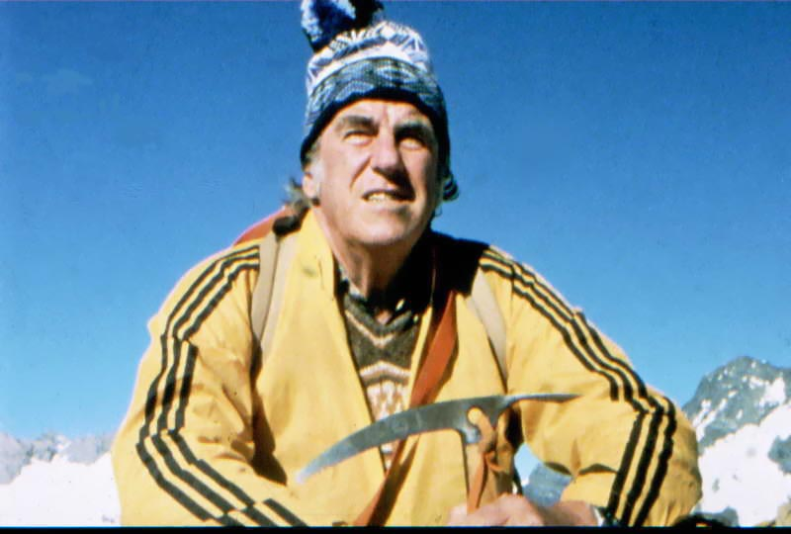
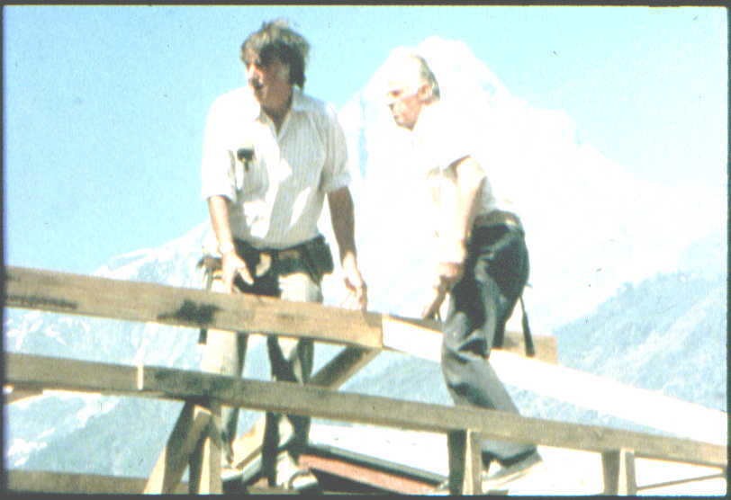
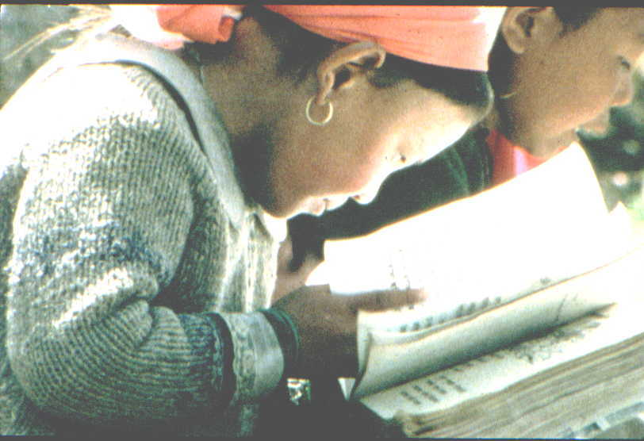

THE
ONGOING CLIMB OF
SHERPA HILLARY

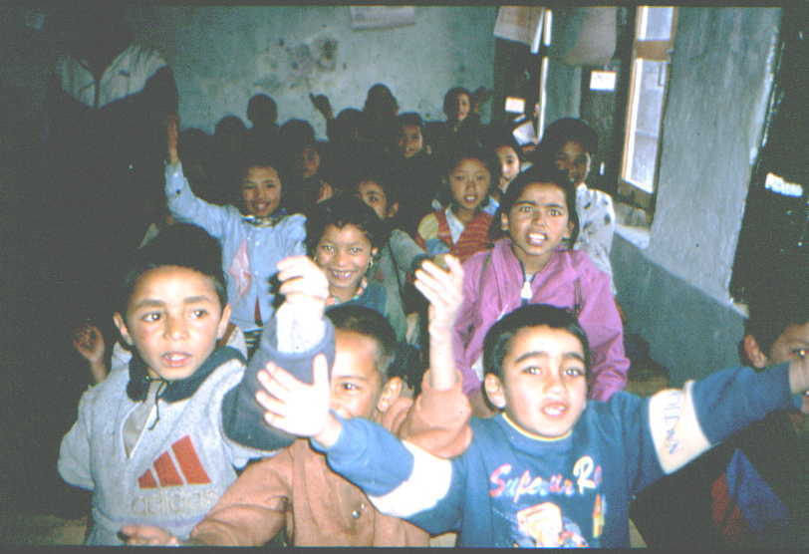
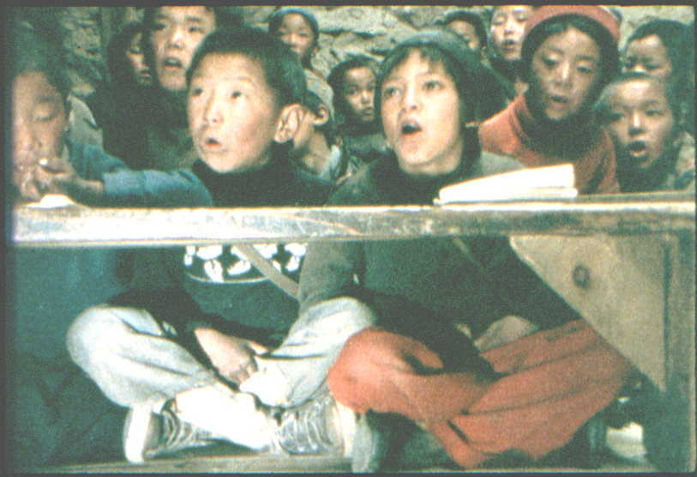
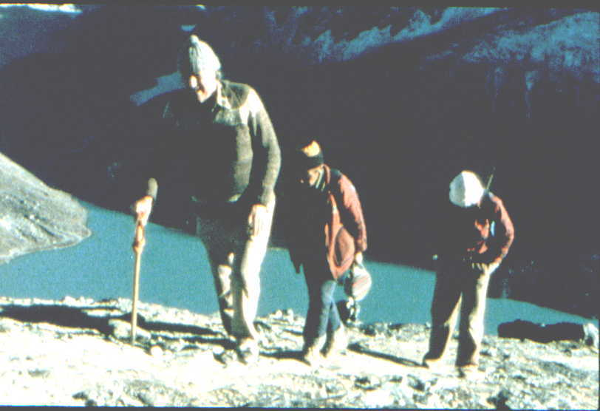

Over 50 years ago Sir Edmund Hillary climbed Everest. Since then he’s gone on climbing higher still. On the sad occasion of his death his Australian filmmaker, Michael Dillon, pays tribute.

We are on a light plane, a Yeti Airways flight no less. We’ve taken off from Kathmandu into a spellbinding world of giant Himalayan peaks.

In front of me sits a large old man in a woollen cardigan, his hair grey and tousled, his face as craggy as the mountains below. He is deep in thought.

Perhaps he’s remembered that today’s the anniversary of the saddest day of his life. The day his wife and youngest daughter took off from the very same airport and minutes later died.

Or perhaps he’s thinking of Everest. It has come into view now. A giant black pyramid above the clouds.

Everest, earth’s highest peak.

How strange it is that our highest peak is almost exactly the right height for us, as though custom built by the gods just high enough to test man to his limit. At twice the height it would be impossible, at half the height inconsequential. But here it is, the ultimate challenge, 8850 metres above sea level, just within man’s grasp.

Until 1953, no one knew it WAS within man’s grasp. Many had tried for its summit. Many had died. But 51 years ago two brave men worked their way along its virgin knife-edged summit ridge. On their backs were oxygen cylinders so heavy their weight almost cancelled out their advantage. On their minds, the scientist’s warnings that if their oxygen cylinders stopped working, they would probably die. But ever on these brave men climbed, a beekeeper and a Sherpa.

One of these legendary heros, Tenzing Norgay, is long dead. The other sits in front of me, Sir Edmund Hillary. Everest, that great event in his life, has faded from view now, and his face warms as the plane banks to reveal the terraced hillside villages of the people of Everest, the Sherpas. Suddenly the ground rushes to meet us and we are bumping along a grassy airstrip well known to Hillary - it was he who built it.

A huge crowd surges forward as Hillary pauses at the doorway of the plane to take in a lungfull of thin air.
But what the atmosphere lacks in oxygen it makes up for in affection. There is love in everyone’s eyes, welcome scarves and flowers in everyone’s hands. Soon Hillary is amongst them, embracing a doctor from a hospital he has built, a nurse from a health clinic he has built, a pupil from one of thirty schools he has built, and other players in his 40 years of secret service to the people of Everest. The man who climbed their highest mountain has gone on climbing higher, into their hearts.

How he would have laughed if you’d told him his life would be like this. I have an image of him back in 1931 in his own rural setting, a bee farm out of Auckland. He is 12, short and scrawny, uncomfortable in his own body, uncomfortable amongst others. At school he prefers the company of the ants in the playground to his fellow pupils and in the physical education class he has been placed in the hopeless squad. I imagine ambushing him as he ambles along in his ill fitting overalls carrying beehives, and confronting him with that big red book, “Edmund Hillary, this will be your life. This may surprise you Edmund, but one day you will be the most famous New Zealander in history. Your face will be on the currency. The Queen will knight you not once but twice. You will have medals galore and eight honorary doctorates. And a mountain people you don’t yet know will love you like a god.”

The mountain people are leading him up a hill now, one of his oldest Sherpa friends supporting him by the arm, others poised to help should Hillary’s eighty year old body falter. For over forty years they have watched him come to them, in the early years trekking for weeks from Kathmandu with hundreds of porters carrying building supplies. Now he comes by air and less often. But each visit is treasured. And each visit they know may be his last.

He isn’t here to take the air, nor here out of nostalga. He is here to work. He and his team. One of his team is walking beside him, a bearded man with a twinkle in his eye, also about eighty years old, his name George Lowe. Lowe and Hillary were the two New Zealanders on that successful British Everest Expedition of 1953 and the best alpine climbers on it. If they’d had their way they would have climbed to the summit together but fate, or rather expedition politics, decreed otherwise. Not only did the leader John Hunt not countenance a colonial summit team upstaging the English team members. Hunt had even dropped them from the expedition some months prior to departure, but reinstated them after being persuaded quite prophetically by the English team members that Hillary and Lowe’s alpine skills could well mean the difference between success and failure.

And here they are again, that little known team of Hillary and Lowe, climbing up a Himalayan slope with their Sherpa friends, heading off to work.

They’ll tell you it isn’t work, tell you it’s the most satisfying thing they have done in life and they’ll tell you it all began around a campfire some years after that successful Everest climb in 1953. Some Sherpa friends were sharing the fire with Hillary and Lowe when Hillary asked his head sherpa, “ Urkein, if there was just one thing we could do for our Sherpa friends what would they want it to be”. The reply was immediate. “Sir, we would like a school for our children.”

Next year Hillary and his team built a simple school in the Sherpa village of Khumjung and soon the first batch of eager barefoot Sherpa children, faces brightly polished for the occasion, stepped into their wooden benched classroom and began a journey that would take some to incredible heights.

When word spread through other villages and other valleys, Hillary was avalanched with petitions. At Thami village the monks and elders composed a petition that was presented to Hillary by a 10 year old boy. They had written “ Our children have eyes but still they are blind. Please build a school in our village too.”
So next year Thami village, where Tenzing Norgay had grown up, had a school of its own.

One school, two schools, another and another. Hillary and his teams have now built thirty of them, as well as two hospitals, two airstrips, many bridges and many health clinics. A forty year labour of love, fashioning rocks he used to climb into school and hospital walls, working with Sherpa and Western building teams, including his brother Rex who worked as building foreman on these projects for twenty five consecutive years.

And now Hillary is back. He has reached his hotel now and quickly prepares for work. He’s a hundred kilometers south of his first school project but his work now has extended this far and keeps on extending.
There is always another valley, another mountain of requests. And petitioners are already gathered.

Soon Hillary is meeting them along with Ang Rita, the full time administrator of Hillary’s Himalayan Trust. Ang Rita was in the first batch of barefoot children from Hillary’s first school and went on to top the school leaving certificate in the whole of Nepal. Now he is Hillary’s right hand man, based in Kathmandu from where most of Hillary’s projects are administered. But the hillfolk know that Hillary always comes with a rucksack of rupees for on the spot discretionary aid and quietly wait with their written petitions, sealed in envelopes, entwined in silk scarves.

The first petitioner is a carpet maker, a polio victim. He has four sons to support and politely requests some help to enable at least some of them to stay in school rather than have to find work. The next petitioner’s house was destroyed in a landslide after heavy rain. He has saved 20,000 rupees towards rebuilding and needs 40,000 rupees more. Hillary’s funds are limited, and educational, health and community concerns take precedence, but he can’t find it in his heart to leave the man’s long journey totally unrewarded and offers him 10,000 rupees.

Circling the group, taking photos, is Hillary’s son Peter, shuffling a little painfully having only recently returned from hauling a heavy sled uphill for 84 days to the South Pole.

Nothing’s been too easy in life for Peter. As the son of the most famous New Zealander it’s been hard for Peter to blossom as his own person in the giant shadow of his father. But he’s stepped well out of that shadow now , followed his father’s footsteps up Everest in 1990 and has recently followed his own footsteps to the summit of Everest again.

Peter was the first child born to Hillary and his wife Louise, whom Hillary had courted in Sydney where she was studying music. Two other children soon followed, daughters Sarah and Belinda. By then Hillary’s building activities in Nepal were in full swing and it wasn’t long before three little Hillary children were carrying rocks along with Sherpa children, each doing what they could. These family trips to Nepal, living and working with the Sherpa people, were the happiest times in Hillary’s life, and 1975 was meant to be the happiest time of all.

That year Hillary, Louise and their now teenage children had decided to spend the entire year in Nepal. Hillary had gone on ahead to supervise the building of his second hospital and his family would join him in stages. His wife Louise and youngest daughter Belinda, 16, would be first in and on March 31st 1975 they set off with the family dog and some Sherpa friends to Kathmandu airport to fly in to join him. Louise had always been fearful of light planes and wanted to walk in , but Hillary had persuaded her to fly.

A young New Zealand pilot met them at the airport and soon they were taxiing for takeoff. Perhaps in the excitement of transporting half the Hillary family , the pilot had omitted one pre-flight check. He had forgotten to remove the pins that unlock the tail flaps. The plane took off, the tail flaps still locked in stall position. It came crashing down into a field killing all on board.

Hillary, standing on the mountain airstrip on which they should by now have landed, had a premonition that something terrible had happened, and a friend soon arrived by helicopter to break the dreadful news. Hillary helicoptered back to Kathmandu and felt compelled to land at the crash site. He would have nightmares for years to come.

That night Hillary cremated the two people he loved most in the world, his wife and youngest daughter. And his only wish that night was to join them. For days he struggled with inconsolable grief made worse by his belief that it was all his fault, that he’d made them fly rather than walk. His two remaining children, Peter and Sarah on arrival in Kathmandu were warned by their grandmother “Your father will never be the same again. He’s heavily drugged, curled up in a ball, sobbing”.

It was the hardest thing that tough man ever did, clawing himself back from the brink of suicide. He would stay alive, he decided, for what was left of his family. He would stay alive because of his responsibilities to the Sherpa people. He would return to the hills and his half completed hospital, and work and weep with his Sherpa friends.

Hospital completed, Hillary returned to Auckland. The family house felt like an empty shell and he felt the same. As part of his self-healing he would throw himself into the organisation of an expedition he and his late wife had often talked of doing together, journeying by jetboat along the entire length of India’s River Ganges.

It would prove an extraordinary expedition, in Hillary’s opinion his most memorable ever. No expedition in history had ever been done in such public gaze. You could hardly see the Ganges banks for people, hundreds deep, here to catch a glimpse of these magic boats and the hero of Everest, Sir Hillary. Whenever Hillary ventured ashore he was mobbed by autograph hunters, a lethal occupation in India, and Service clubs in every riverside town fought tooth and nail for the right to host Sir Hillary and his team for lunch. In one town the Lions wanted to have Hillary for lunch but the Rotary Club won the honour. This was too much for the enraged Lions. They roared into the Rotary lunch and fur flew.

In the midst of all this mayhem there were quiet moments. Nights camped in remote villages, beautiful sunsets. And transforming moments too. In the holy city of Varanasi, in the midst of a jetboat blessing ceremony conducted by a charismatic young priest, Hillary felt the years of dark depression start to lift, felt the sun begin to rise again in his soul.

It was a milestone in Hillary’s long quest to become himself again. More years of schoolbuilding would continue to help as well as a happy development in his personal life.

Hillary and his late wife Louise had had as closest friends Peter Mulgrew and his wife June. Peter had been on expeditions with Hillary in Antarctica and the Himalayas and they and their wives had been an inseparable foursome. But in 1979, four years after Louise’s death, Peter Mulgrew died, also in an air crash. At the last moment he had taken Hillary’s place as guest commentator on an Air New Zealand day flight to Antarctica, the flight that crashed into Mount Erebus, killing all on board.

The foursome was now a twosome. Sir Edmund Hillary and June Mulgrew. And soon the twosome became one. When in 1985 New Zealand Prime Minister David Lange invited Hillary to be New Zealand High Commissioner to India (a brilliant move by Lange considering Hillary’s semi divine status in India – it’s always useful to have a god as your country’s representative) Hillary asked whether he could take June to India as his social secretary.

During these High Commission years Hillary, with June at his side, continued his work in the Everest region, and could often be seen not on the cocktail circuit but high on a schoolhouse roof, sleeves rolled up banging in nails- the High Commissioner with a hammer.

And now they are here in Nepal again, Sir Edmund and June, Lady Hillary. Now long married and now long associated in this work in Nepal, they are sitting together listening to petitions. Three red robed monks have come with photos of their distant monastery and are seeking five hundred thousand rupees to enlarge its courtyard. They want to pull down three of its sides and rebuild. June asks if they can perhaps extend the courtyard by moving just one side. For ten minutes all the pros and cons are discussed. Hillary knows it is an important monastery in its region and knows the importance of monasteries in the preservation of Sherpa cultural values. And because Sherpa family land is too scarce to subdivide, the monasteries have always provided a useful vocation for younger sons. Hillary weighs up their request, “What do you think about three hundred thousand rupees?” The spokesman is happy. “That’s a big contribution. They will start work right away”. The monk’s faces are beaming, as is June’s. “It’s always good to see their reaction. Three hundred thousand is probably what they wanted”.

Just up the hill from their hotel stands a little schoolhouse Hillary has recently been upgrading with skylights and new floors. Every morning we hear an oxygen cylinder being struck, summoning children to school, and know throughout these valleys 29 other Everest oxygen cylinder school bells are ringing out and that a thousand children are beginning their often hours long journey to school. Now we see them, the children of this closest school, Paphlu primary school, their dusty red school uniforms held together by an equal measure of buttons and safety pins, a fresh handkerchief pinned to their chest. But today they are not just carrying their schoolbooks. Each child has a beautiful arrangement of red rhododendrons they must have spent hours preparing. For today is a special day. Edmund Hillary is visiting their school.

The teachers form the children into a line that stretches from the school almost to Hillary’s hotel. The school band has assembled on a nearby rock with their shiny collection of drums. Hillary donated the drums last year and they are now banging them so vigorously he’ll probably have to give them another set next year. Hillary is now making his way along the line of beaming children, each one handing him their own little gift of thanks, the flowers from their forest. One little boy, when Hillary gets to him is so overawed he freezes, flowers still in his hand, until he’s thumped on the back by the boy next to him.

At the school Hillary and his party are led through various rooms. In one room George Lowe smiles and draws Hillary’s attention to a large framed pencil drawing of a baby. It is a reproduction of a photo of Hillary as a baby recently published in a Hillary Biography, and in big letters underneath the framed sketch is the title “Edmund Hillary- 20 months old”. It dwarfs the picture next to it, a portrait of the King of Nepal.

The tour continues. The class of seven year olds does a spirited rendition of “The Wheels on the Bus” song. It matters not that they’ve never seen a bus and rarely a wheel. They sing with such glee and passion, almost poking out each others eyes with their expansive hand gestures. Next it’s the eight year olds with the highest ever rendition of “ Kookaburra sits in the old gum tree”. Another class is in the playground, the entire class running around in a circle singing “Fire on the Mountain, run, run, run.” At the end of each verse the teacher calls out a number such as five and the children have to instantly gather in groups of five.
It’s an interesting and energetic way to teach numeracy and is one of many innovations that have come out of Hillary’s recent teacher training programme. It was Hillary’s Everest partner, George Lowe, who on retirement as Her Majesty’s Inspector of Schools in the UK, travelled incognito around all the Hillary schools and recommended the development of such a programme, and the results have been spectacular. The team of Hillary and Lowe, Hillary building schools, Lowe, supervising the teaching standards within, has pulled off something special, just as they did in 1953.

It is May 26th 1953 and the summit teams are poised. The monsoon’s on the way and they know they’ve just days to succeed, or fail like all before them. Already Hillary and Lowe have played a crucial role in getting them this far, both forging the route through the icefall, and Lowe establishing the route up the Lhotse Face to the South Col, a crucial but exhausting eleven day task. Hillary knew this selfless task would put Lowe out of summit contention so he looked around for the next best partner and chose Tenzing who he admired as a person and as a strong, motivated climber. And so the summit teams were formed. Hillary and Tenzing ,and the Englishmen Evans and Bourdillon. The English team would be given first go.

On May 26th Tom Bourdillon and Charles Evans set off from the South Col directly for the summit. They were using a prototype oxygen system (later refined by NASA) developed by Bourdillon and his father. It permitted a very strong flow of oxygen but had to be used in a short time frame, hence speed was of the essence. But it was a bad snow year, the surface crust too thin, every upward step breaking through the crust and into often waist deep soft snow. On the South Summit they knew they wouldn’t make it but Bourdillon in despair kept going. Evans yelled to him “Tom, you won’t see your wife again”. Bourdillon collapsed in the snow weeping and together they descended.

Now it’s Hillary and Tenzing’s turn. They have a three man team in support to help them establish a higher camp. One is a sherpa Ang Nyima, another an Englishman, Alf Gregory, and the other is George Lowe. Lowe, who had every right to be terminally exhausted from his Lhotse Face efforts, is here, as fit as anyone, and it is Lowe who cuts the steps to the highest camp, carries the most, and puts up Hillary and Tenzing’s tent. They discuss whether Lowe should stay with them for tomorrow’s summit push, for a three man team may be valuable if the route proves very technical. But there is insufficient oxygen for three. Lowe wishes them well and walks downhill into obscurity.

Next morning Hillary and Tenzing set off for the summit. Snow conditions are dangerous. Slopes could avalanche, and on any other mountain they would have turned back. But nothing will stop these men, not the danger, not their pitiful oxygen supply, not the steep, jagged, endless summit ridge. At 11.30 am on May 29th, the New Zealand beekeeper and the Sherpa, two brave men from the fringes of world society, embraced on the roof of the world.

Some days later Hillary will write to his mother.

“Dear Mother,
Well I may not have produced much joy or happiness in the world, but at least I’ve helped make the Hillary name a bit famous. It was a tremendous thrill to me to reach the summit of Everest, especially as I was going particularly well. I’d be interested to see all the cuttings from the Auckland papers if you’d like to keep them for me.”

There were more than cuttings. This was front page stuff, perfectly timed. The news broke on the morning of the Queen’s coronation.

Half way back to Kathmandu Hillary opened a letter addressed to Sir Edmund Hillary KBE. The news he’d been made the century’s youngest knight quite rocked the shy beekeeper. How now could he walk down the main street of his country town in his old overalls. He would have to buy a new pair of overalls.

The entire team flew to London, and the New Zealanders Hillary and Lowe for months bemusedly shared a black tie existence, treating the upper class with respect but not too much respect. They wouldn’t attend a function, they joked to each other, unless there was at least one Duke present. A long lecture tour followed which also served as Hillary and his new wife Louise’s honeymoon. George Lowe came along too and became godfather to Hillary’s first child, Peter. Peter in turn would name his first son George.

Then it was back to their day jobs, Hillary to his bees, Lowe to his school teaching. They reunited on other expeditions in Antarctica and the Himalayas and were there together around the campfire when the Sherpas requested that first school. And so began the chain of events that’s seen the old team of Hillary and Lowe climb higher than Everest in Sherpa eyes.

When this humanitarian work began, over forty years ago, Sherpa civilisation was at a crossroads, their old way of life of trading with Tibet cut off by the Chinese invasion. The opening of the Hillary schools would foster alternative vocations for Sherpa children, helping many, through their knowledge of English, to move faster through the ranks of trekking companies, many of whom they now own. Helping the brightest into occupations undreamed of. The Medical Superintendents at both Hillary Hospitals are Sherpa doctors, once schoolboys racing to the sound of a Hillary school bell. Another, now a PHD in Forestry, is Warden of Mount Everest National Park. Another boy, who used to make aeroplanes from pieces of left over school building wood, now pilots jumbo jets in Europe. Another boy, who used to drive his teachers mad by drawing helicopters on every available surface, is now a helicopter pilot.

Next morning the flying Sherpa, Captain Dawa , arrives with his helicopter to transport Hillary and his party to a distant school, Mount Everest School- its pupils mostly sons and daughters of Tibetan refugees.

It’s a long steep slope up to the school from the level ground where the helicopter has landed. A long hard climb. Once again the path is lined with beaming children offering Hillary flowers and silk scarves. But the atmosphere is muted. It is clear Hillary is suffering. He climbs slowly, his face is deathly pale and he is slurring his words. It is painfully clear that yet again he is playing Russian roulette with his respiratory system, and all are concerned that this may be the time he actually dies.

Ever since Everest Hillary has had problems with altitude. On a subsequent Himalayan peak he had a slight stroke and at the end of his Ocean to Sky Ganges Expedition he had a very lucky escape indeed. After abandoning the Ganges when the river became a waterfall, Hillary and his team set out to climb a peak as a symbolic end to the journey. Hillary was fifty nine but insisted on carrying as much as everyone else. Next morning at the highest camp he collapsed with the most deadly form of altitude sickness – cerebral oedema.

There was no cure except rapid descent. The team, old climbing friends, collapsed his tent around him, and each man holding a tent rope began hauling Hillary and tent down the slope for thousands of feet, Hillary’s son Peter out front pulling like a draught horse. When the slope was too steep for sledding they took turns carrying Hillary. The swiftest of the climbers had long since rushed down valley to an Indian army post to request a helicopter, and next morning it arrived. Just before it did a whole platoon of Indian Mountain Rescue troops stormed up the hill to help save the life of their Everest hero. When the helicopter took off with Hillary safely aboard we expedition members and the Indian troops embraced and wept with relief, knowing our great friend and their great hero would live.

But here he is, eighty years old, tempting fate once more. Today’s summit is Mount Everest School, still a long slope away, and it’s clear Hillary is putting more effort into this climb than he did on Everest in 1953. Once again he is triumphant and sits as guest of honour as the children sing to him

On this Wonderful Day,
We the children of Mount Everest School,
We wish you happy welcome.
Edmund Hillary
Edmund Hillary.

They sing standing to attention evenly spaced around their playground, each boy and girl in a neat school uniform complete with tie. The school band strikes up and the children begin a kaleidoscopic display of calisthenics which ends with the children all crouched in prayer position but still in formation. The pattern they have formed is the international symbol for peace.

Some days later Hillary travels by helicopter to spend some time in the villages closer to Everest, where his work began. The trekking trails to Everest pass through these villages and young western trekkers stare at this old man wondering what on earth he is doing here in young peoples territory. Often I have watched Hillary sit quietly in tea shops while young trekkers, not recognising him, boasts about their own trekking exploits. I once filmed Hillary up here sitting on a rock, casually holding an ice axe, reminiscing with his son Peter. An American trekker chanced upon us, watched for a while, and unable to contain himself any longer, said to Hillary “Hey, Bud, that’s not the way to hold an ice axe”, and proceeded to show him how to do it. Hillary thanked him but said nothing else. The American went off, still oblivious to whom he had instructed. Was it, I wonder, the bee stings from his youth that innoculated him from Great Man syndrome? I know no man with less reason to be humble. Yet know no man more humble.

In the village of Kunde Hillary enters his second home, the house of Ang Dooli, the wife of Hillary’s dearest Sherpa friend, Mingma Tsering. Mingma was the foreman of all Hillary’s early building projects. He could neither read nor write, but had a memory for detail that outrivalled a computer.

Mingma is dead now but his wife Ang Dooli, half the height of Hillary, bustles about gathering ingredients for Tibetan tea. This house was the Hillary family base in the happy days when Hillary, his wife Louise and their children were all here together working. And with Louise now dead, Ang Dooli is the Hillary children’s surrogate mother, their sherpa mother.

In a corner of a room adorned with Hillary family photos, sits Ang Dooli’s deaf mute son Temba. He is hard at work on his latest painting, a beautiful stylised landscape of the region complete with a yeti or two. Of Ang Dooli’s eleven children, Temba was one of only three who survived childhood, a typical statistic which made Hillary realise early on how urgent it was to do something about the Sherpa’s health needs in a region where iodine deficiency and other maladies were endemic. In 1965 he built Kunde hospital which now treats nine thousand patients a year. In 1975 he built a 20 bed hospital down valley in Paphlu and has built and staffed over a dozen village health clinics.

Downhill from Ang Dooli’s house is Khumjung school. Hillarys first school. Forty years ago it was a few prefabricated buildings. Today it’s a multi- building complex that includes a secondary school. For every one of those forty years Hillary has come back, ever alert to any upgrading that needs doing and to the general issues of the region , environmental issues included. In 1983 I saw him lead the entire school, pied piper like, up the hill , each child carrying a pine sapling to plant on the denuded slope, to create once more a forest. That same year Sherpa Tenzing joined Hillary at the school to celebrate the 30th anniversary of their Everest climb. They sat together laughing uproariously as the children reenacted their famous climb on a rock in the school playground.

That would be the last occasion Hillary and Tenzing would be together in the Himalayas. Three years later, in 1986, Tenzing died of pneumonia.

Tenzing, like many Sherpa second sons, had trained to become a monk but the life didn’t suit him and he left for distant Darjeeling in the hope of getting portering work on the Everest Expeditions that used to pass through there. After climbing Everest Tenzing continued to live in Darjeeling where India’s Prime Minister Nehru had set up a lifetime position for him at the Indian Mountaineering Institute. With his modest salary, increasing family responsibilities and his physical distance from the people of Everest, Tenzing did feel saddened that he couldn’t do more for his own people, and there developed some degree of unease between he and Hillary.But in Tenzing’s declining years, which coincided with Hillary’s years as New Zealand’s High Commissioner to India, they saw a lot of each other and rekindled the deep friendship and respect they shared in 1953.

It is some days later and Hillary is again down valley at Paphlu. The sun is sinking lower in the sky. Hillary is sitting indoors, with George Lowe, listening to more petitions for help. Already it has been a long day. That morning at a new monastery partly built with Hillary funds, Hillary was taken by surprise when, to the accompaniment of gongs, trumpets, and horns, the monks started dressing him in the clothes of a High Lama, topped off with a huge yellow sail shaped hat. It was a happy occasion with much banter, Peter suggesting to his dad that he should wear the garb next time he walks up the street to post a letter in Auckland. But everyone knew it was a special moment, possibly the first time a westerner has ever been made an honorary High Lama.

Now High Lama Hillary is sitting in mufti, in his old corduroys and cardigan, again listening to petitions. A teenage Sherpa girl, with clasped hands and pleading eyes tells her story. Her parents have died and she needs financial help to be able to stay in school. Behind her, silhouetted in the curtains by the setting sun, are many more petitioners waiting patiently outside. Hillary hands the young girl some money and in an old exercise book makes a note, Young Sherpa Girl – Nine thousand rupees. Above her name are those who came just prior to her- limping man, scholarship boy, ill children… On another page Hillary has listed next years tasks - a school to be renovated, a hospital upgraded, a new health clinic, and other tasks more satisfying, more lasting, than a footprint on a mountaintop.

The sun is setting now. The days work almost done. Hillary is exhausted. George Lowe is reflective, and tries to put words to his thoughts. “There is no end to the need here. There’ll always be people at the door. It is an uphill task. But that’s Ed’s strength, uphill tasks. I’ve seen it on Everest and I see it still. He’ll just keep plugging on until he can’t go one step more.”

-----------------------------

